2025 6th Asia-Pacific Conference on Image Processing,

Electronics and Computers（IPEC2025）

**Invitation Letter**

**Organized by**

Beijing University of Technology

To whom it may concern,

2025 6th Asia-Pacific Conference on Image Processing, Electronics and Computers (IPEC 2025) aims to bring together researchers and scientists from image processing, electronics and computers and other related areas, to identify new issues, and to shape future directions for research. It will be organized by Beijing University of Technology and will be held during April 18-20, 2025 in Dalian, China.

The Conference provides opportunities for the delegates to exchange new ideas and application experiences face to face, to establish business or research relations and to find global partners for future collaboration.

Herewith, on behalf of Organization Committee of IPEC2025, we are pleased to invite:

Name:

Affiliation:

to attend the conference and give an oral presentation.

We look forward to seeing you in Dalian, China!

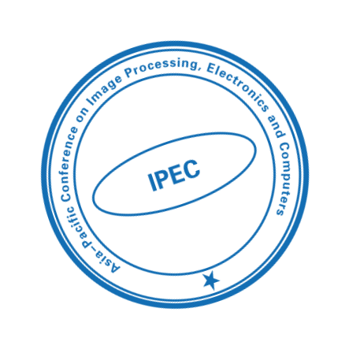

Organization Committee of IPEC2025

E-mail: contact@acipec.org

Website: http://www.acipec.org/