2026 7th Asia-Pacific Conference on Image Processing, Electronics and Computers (IPEC 2026)

**Invitation Letter**

To whom it may concern,

2026 7th Asia-Pacific Conference on Image Processing, Electronics and Computers (IPEC 2026) will be held during May 22-24, 2026 in Dalian, China. It will be hosted by Dalian Jiaotong University, in association with Beijing University of Technology, Chengdu University of Information Technology, SouthWest Petroleum University, Nanchang Hangkong University.

It aims to bring together researchers and scientists from image processing, electronics and computers and other related areas, to identify new issues, and to shape future directions for research. The Conference provides opportunities for the delegates to exchange new ideas and application experiences face to face, to establish business or research relations and to find global partners for future collaboration.

Herewith, on behalf of Organization Committee of IPEC 2026, we are pleased to invite:

Name:

Affiliation:

to attend the conference and give an oral presentation.

We look forward to seeing you in Dalian, China!

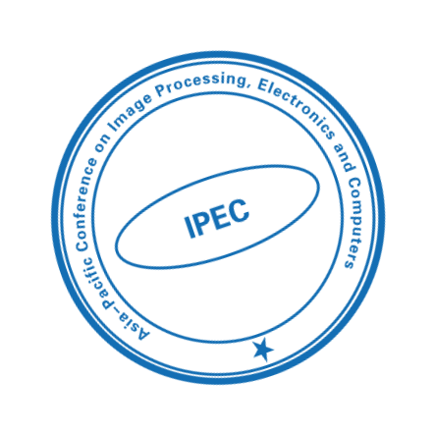

Organization Committee of IPEC 2026

E-mail: [contact@acipec.org](mailto:contact@acipec.org)

Website: <http://www.acipec.org/>